**Title (Please provide a title of 15 to 20 words that should be concise and informative)**

Author Name*, Author Name, Author Name

Affiliation, Department, Institution, City, Country

Affiliation, Department, Institution, City, Country

Affiliation, Department, Institution, City, Country

|  |  |
| --- | --- |
|  |  |
| **ABSTRACT**  Abstract set a maximum of 250 words, including keywords and article classification. The following points should always be featured: Purpose: This is where you explain ‘why’ you undertook this study. If you are presenting new or novel research, explain the problem that you have solved. If you are building upon previous research, briefly explain why you felt it was important to do so. This is your opportunity to let readers know why you chose to study this topic or problem and its relevance. Let them know what your key argument or main finding is. Design/methods/approach: This is ‘how’ you did it. Let readers know exactly what you did to reach your results. For example, did you undertake interviews? Did you experiment in the lab? What tools, methods, protocols, or datasets did you use? Findings: Here, you can explain ‘what’ you found during your study, whether it answers the problem you set out to explore, and whether your hypothesis was confirmed. You need to be very clear and direct and give exact figures rather than generalize. It is important not to exaggerate or create an expectation that your paper will not fulfill. Research implications/limitations: Here, you can explain characteristics of design or methodology that impacted or influenced the interpretation of the findings from your research. They are the constraints on generalizability, applications to practice, and utility of findings that are the result of how you initially chose to design the study or the method used to establish internal and external validity of the result of unanticipated challenges that emerged during the study. Your research may have multiple limitations, but you need to discuss only those limitations directly related to your research problems. Originality/value: This is your opportunity to provide readers with an analysis of the value of your results. It’s a good idea to ask colleagues whether your analysis is balanced and fair, and again, it is important not to exaggerate. You can also conjecture what future research steps could be. | **ARTICLE HISTORY**  Received: 1 Maret 2022  Accepted: 25 Juni 2022  **KEYWORDS**  Type your keywords here, between 3 and 6, separated by semicolons |

# Introduction

The introduction should outline the aims of your paper and describe why the topic is important and what it contributes to the body of knowledge. You should also provide background to the research project, highlight the structure of the paper, and explain what made you decide to research this topic/write the article. Provide broad definitions and discussions of the topic and incorporate views of others (literature review) into the discussion to support, refute, or demonstrate your position on the topic. Please highlight controversial and diverging hypotheses when necessary. Finally, we briefly mention the main aim of the work and highlight the principal conclusions. As far as possible, please keep the introduction comprehensible to scientists outside your particular field of research.

# Methods

This section describes how the research was conducted. The primary materials of this section are (1) research design; (2) population and sample (target of research); (3) data collection techniques and instrument development; (4) and data analysis techniques. For research using tools and materials, it is necessary to write down the specifications of the tools and materials. The tool specifications describe the sophistication of the tools used, while the material specifications describe the types of materials used. Qualitative research such as classroom action research, ethnography, phenomenology, case studies, and others, it is necessary to add the presence of researchers, research subjects, informants who helped during the research and ways to explore research data, location and duration of research as well as descriptions of checking the validity of research results.

These are examples of tables and figure:

**Table 1.** An example of a table

|  |  |  |
| --- | --- | --- |
| An example of a column heading **(autofit window)** | Column A | Column B |
| Times New Roman 10pt, single space | 1 | 2 |
| And another entry | 3 | 4 |
| And another entry | 5 | 6 |

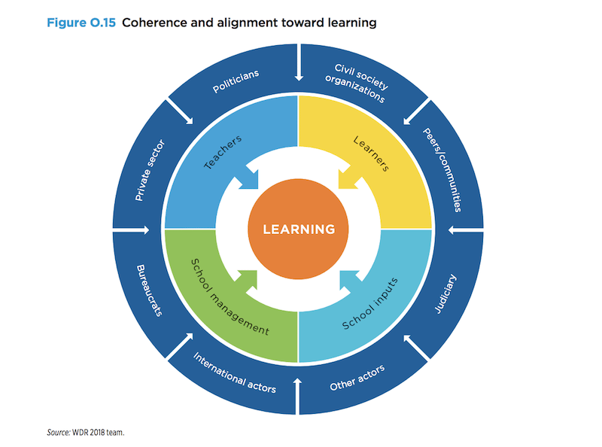

**Figure 1.** Coherence and alignment toward learning

(Source: WRD 2018 team)

While submitting an article, authors will be asked to Transfer Intellectual Property Rights and Exploitation Rights. Acceptance of the conditions will ensure the widest possible dis­semination of information. Subscribers may reproduce tables of contents or prepare lists of articles including abstracts for internal circulation within their institutions. Permission of the Publisher is required for resale or distribution outside the institution and for all other derivative works, including compilations and trans­lations (please consult http://www.elsevier.com/permissions). If excerpts from other copyrighted works are included, the author(s) must obtain written permission from the copyright owners and credit the source(s) in the article.

# Result

This section may be divided into subheadings. It should provide a concise and precise description of the experimental results, their interpretation, and the experimental conclusions that can be drawn.

Numbered lists can be added as follows:

## *Subheadings*

### *Subheadings*

### *Subheadings*

## *Subheadings*

### *Subheadings*

### *Subheadings*

## *Subheadings*

### *Subheadings*

### *Subheadings*

The text continues here.

For Results, provide sufficient detail to allow the results to be meaningful and informative. For Discussion, this should explore the significance of the results of the work, not repeat them. A combined Results and Discussion section is often appropriate. Avoid extensive citations and discussion of published literature.

# Discussion

Authors should discuss the results and how they can be interpreted from the perspective of previous studies and the working hypotheses. The findings and their implications should be discussed in the broadest context possible. Future research directions may also be highlighted.

# Conclusion

The conclusion should summarise the main state of play at the point of writing and consider the next steps. Summarise and conclude, restating the main argument and presenting key conclusions and recommendations-state how your findings/new framework can be applied in practice. Explain what the implications are for further research.

# Acknowledgment

The acknowledgment is in a separate section at the end of the article before the references and does not include on the title page, as a footnote to the title or otherwise. List here the sponsors or individuals who provided help during the research (e.g., providing language help, writing assistance or proofreading the article, etc.).

# References

References should relate only to the material you cited within your article (this is not a bibliography). References should be in APA Style 7th Edition and listed in alphabetical order. Please do not include any abbreviations. Any additional references should be included in an Additional Reading section.